**Experiment 1**

**Aim** : Case Study on any application(netflix) wrt it’s big data architecture.

**Case Study** :

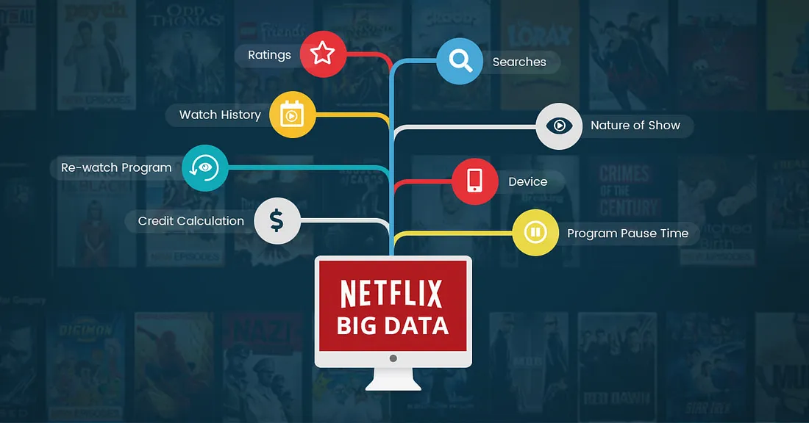

Netflix utilizes extensive viewer data, including demographics, viewing habits, and preferences, gathered over its years in the streaming industry. By employing sophisticated algorithms and mechanisms, the platform anticipates user preferences, suggesting content even before completion. This data-driven approach enhances service efficiency, guiding Netflix in delivering personalized and engaging content to its audience.

Some of these tools and features are:

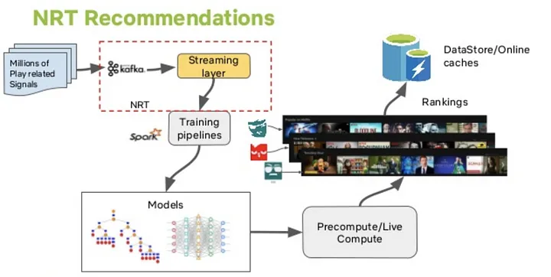

* **Real-Time Recommendation Engine**

With a sea of users, each user generates hundreds of ratings per day based on what they watch, search and add to their watch-list, this data ultimately becomes a part of Big Data. Netflix stores all of this information and using key machine learning algorithms, it builds a pattern indicating the viewer’s taste. This pattern may never match with another viewer because of how everyone’s taste is unique.Based on the ratings, Netflix categorizes its media and suggests the viewer what the recommendation system thinks they might like to watch next.Netflix will know everything.

* **Artwork & Imagery Selection**

The tool behind this is called AVA, which is essentially an algorithm that selects what artworks and images to show to whom. Short for Aesthetics Visual Analysis, AVA sifts through every video available and identifies the frames that are best suitable to be used as artworks.AVA takes a lot of metrics into consideration before finalizing on images, such as facial expressions of actors, the scene lighting, areas of interest, positioning of subjects on screen. It even categorizes and sorts artworks to show to users categorized into several taste groups.

* **Production Planning**

Data plays an integral part when creators come up with an idea about a new show or movie. A lot of brainstorming takes place before anything gets on the paper, and that’s where data comes in.With prior experience in creating new and original content and loads of data about how the viewers perceived the previous content, Big Data helps bring out the possible solutions to many of the challenges faced during the planning phase.These challenges could include identifying shoot locations, time and day of the shoot, and more. Even with simple prediction models, Netflix can save a significant amount of effort put into planning, further reducing expenses.

* **Metaflow**

Netflix has open-sourced Metaflow, their cloud native, human-centric framework aimed at boosting data scientist productivityThe idea behind Metaflow was to shift the focus of data scientists from worrying about the infrastructure of models to solving problems. Metaflow allowed them the freedom to experiment with their ideas by offering a set of fine-tuned features that almost makes Metaflow feel like a plug-and-play framework.

* **Polynote**

Developed and open-sourced by Netflix, Polynote is a polyglot notebook with support for Scala and various other features. Polynote allows smooth integration of JVM based machine learning platform with Python to data scientists and machine learning researchers.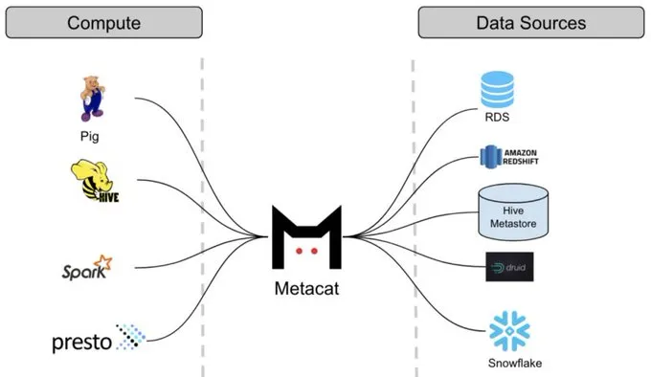

* **Metacat**

The vast pool of data that Netflix operates on is spread across multiple platforms such as Amazon S3, Druid, Redshift and MySQL, to name a few. To maintain seamless interoperability among these data stores, Netflix needed a service.This need for simplicity gave birth to Metacat, whose sole purpose was to provide centralized metadata access for all data stores

* **Druid**

Netflix uses Apache Druid for ensuring that its users get a high-quality user experience every time. Delivering a top-notch user experience every time is not a simple feat. It requires constant analysis of several events, gathering the necessary data and analyzing it. This data could be anything from the playback information, to device information, to measuring platform performance and several others. All these event metrics make raw data complicated, and that’s where Druid comes into play.Druid’s task is to provide real-time analytics on databases where queries execute regularly and at uncertain time-periods. It is highly scalable and offers excellent performance for any given workload.

**Conclusion** : Using big data, Netflix saves $1 billion per year on customer retention.

Big Data plays a critical role in not just deciding the functioning of Netflix but also presents them with newer opportunities to grow. New technologies often bring their fair share of issues with them, but at Netflix, they have been tackling those issues head-on, consistently by taking community inputs. By open-sourcing several of the libraries and frameworks to the community, Netflix aims to improve not just itself, but other companies as well.

**Experiment 2**

Aim : Install Hadoop on a Single Node Cluster.

Theory :

**Apache Hadoop** is an open source framework that is used to efficiently store and process large datasets ranging in size from gigabytes to petabytes of data. Instead of using one large computer to store and process the data, Hadoop allows clustering multiple computers to analyze massive datasets in parallel more quickly.

Hadoop consists of four main modules:

1. Hadoop Distributed File System (HDFS) - A distributed file system that runs on standard or low-end hardware. HDFS provides better data throughput than traditional file systems, in addition to high fault tolerance and native support of large datasets.

2. Yet Another Resource Negotiator (YARN) - Manages and monitors cluster nodes and resource usage. It schedules jobs and tasks.

3. MapReduce - A framework that helps programs do the parallel computation on data. The map task takes input data and converts it into a dataset that can be computed in key value pairs. The output of the map task is consumed by reduce tasks to aggregate output and provide the desired result.

4. Hadoop Common - Provides common Java libraries that can be used across all modules.

How Hadoop Works?

● Hadoop makes it easier to use all the storage and processing capacity in cluster servers, and to execute distributed processes against huge amounts of data.

● Hadoop provides the building blocks on which other services and applications can be built.Applications that collect data in various formats can place data into the Hadoop cluster by using an API operation to connect to the NameNode.

● The NameNode tracks the file directory structure and placement of “chunks” for each file, replicated across DataNodes.

● To run a job to query the data, provide a MapReduce job made up of many map and reduce tasks that run against the data in HDFS spread across the DataNodes.

● Map tasks run on each node against the input files supplied, and reducers run to aggregate and organize the final output.

● The Hadoop ecosystem has grown significantly over the years due to its extensibility.

● Today, the Hadoop ecosystem includes many tools and applications to help collect, store, process, analyze, and manage big data.

● Some of the most popular applications are:

➔ Spark - An open source, distributed processing system commonly used for big data workloads. Apache Spark uses in-memory caching and optimized execution for fast performance, and it supports general batch processing, streaming analytics, machine learning, graph databases, and ad hoc queries.

➔ Presto - An open source, distributed SQL query engine optimized for low-latency, ad-hoc analysis of data. It supports the ANSI SQL standard, including complex queries, aggregations, joins, and window functions. Presto can process data from multiple data sources including the Hadoop Distributed File System (HDFS) and Amazon S3.

➔ Hive - Allows users to leverage Hadoop MapReduce using a SQL interface, enabling analytics at a massive scale, in addition to distributed and fault-tolerant data warehousing.

➔ HBase - An open source, non-relational, versioned database that runs on top of Amazon S3 (using EMRFS) or the Hadoop Distributed File System (HDFS). HBase is a massively scalable, distributed big data store built for random, strictly consistent, real-time access for tables with billions of rows and millions of columns.

➔ Zeppelin - An interactive notebook that enables interactive data exploration.

Screenshots :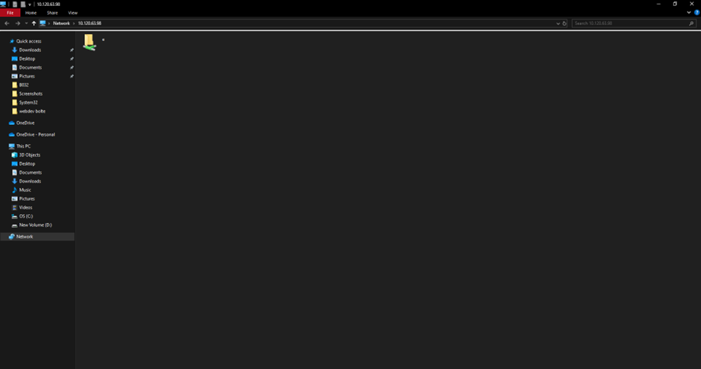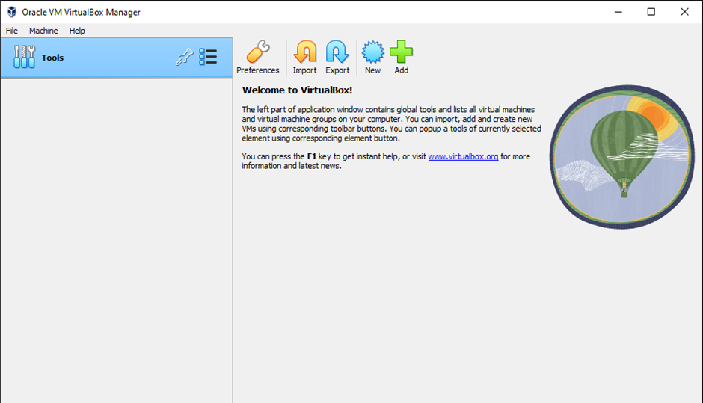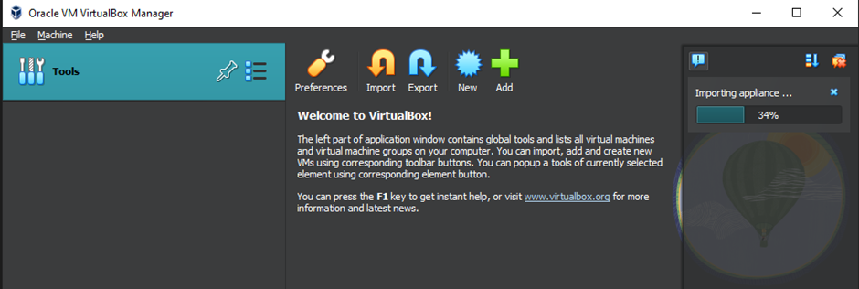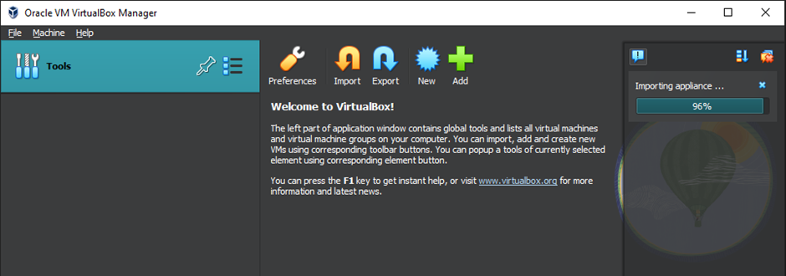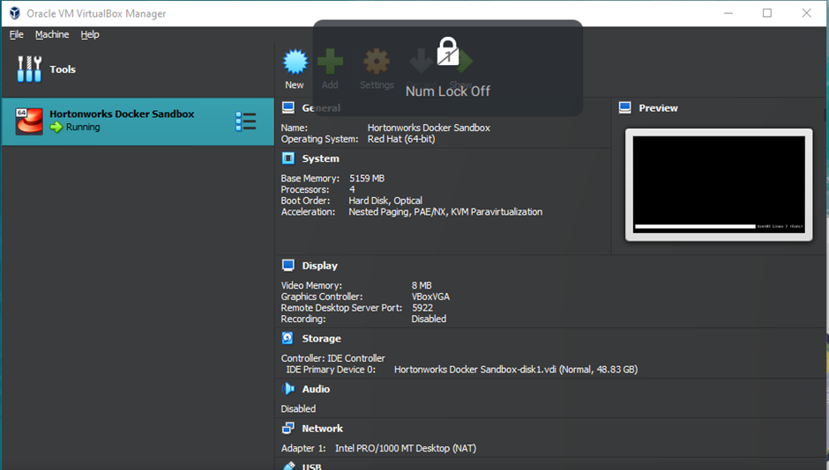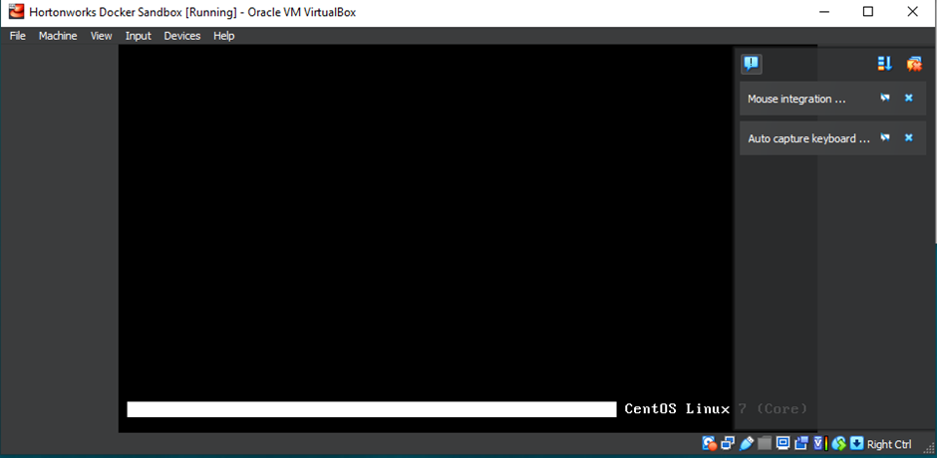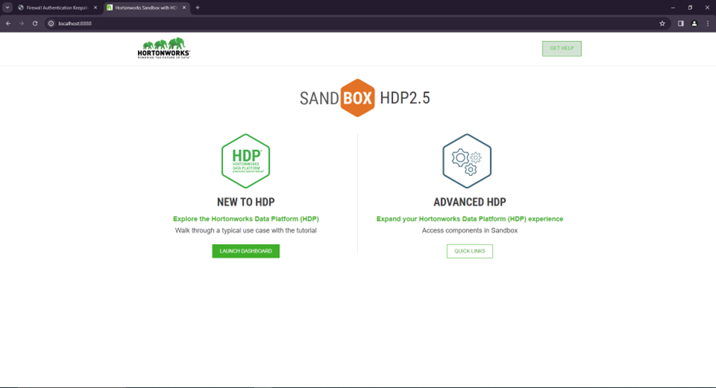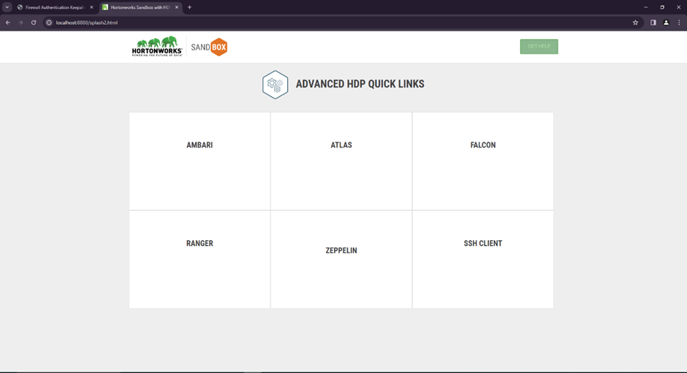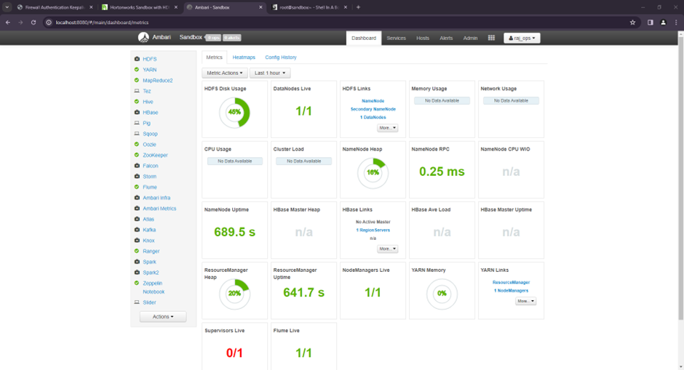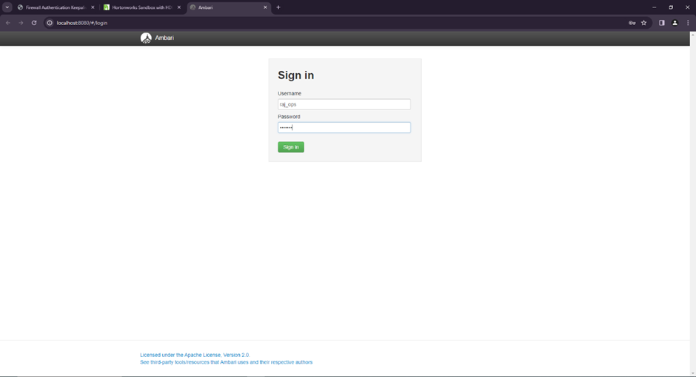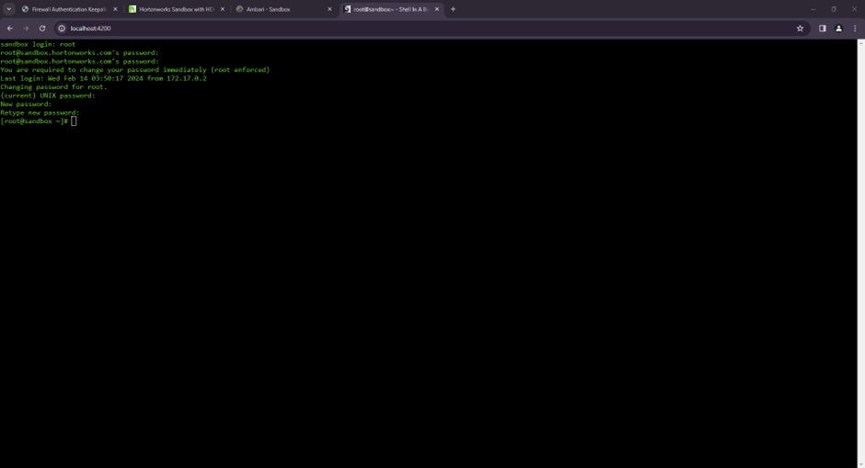

Conclusion : We have successfully installed Hadoop.

**Experiment 3**

Aim : Execute different HDFC commands.

Theory :

Hadoop is a software framework that enables distributed storage and processing of large data sets. It consists of several open source projects, including HDFS, MapReduce, and Yarn. While Hadoop can be used for different purposes, the two most common are Big Data analytics and NoSQL database management. HDFS stands for “Hadoop Distributed File System” and is a decentralized file system that stores data across multiple computers in a cluster. This makes it ideal for large-scale storage as it distributes the load across multiple machines so there’s less pressure on each individual machine. MapReduce is a programming model that allows users to write code once and execute it across many

servers. When combined with HDFS, MapReduce can be used to process massive data sets in parallel by dividing work up into smaller chunks and executing them simultaneously.

**HDFS Architecture**

HDFS is an Open source component of the Apache Software Foundation that manages data. HDFS has scalability, availability, and replication as key features. Name nodes, secondary name nodes, data nodes, checkpoint nodes, backup nodes, and blocks all make up the architecture of HDFS. HDFS is faulttolerant and is replicated. Files are distributed across the cluster systems using the Name node and Data Nodes.

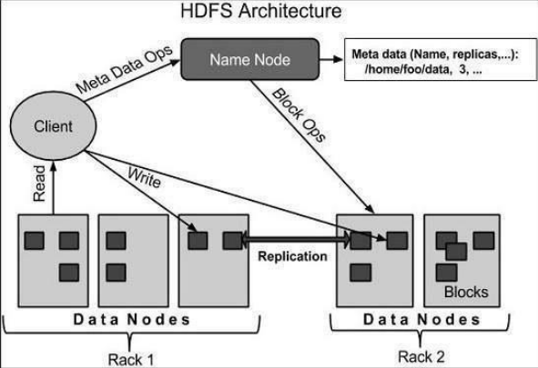

The primary difference between Hadoop and Apache HBase is that Apache HBase is a nonrelational database and Apache Hadoop is a non-relational data store

• Manages the file system namespace.

• Regulates client’s access to files.

• It also executes file system operations such as renaming, closing, and opening files and directories.

Datanode

The datanode is a commodity hardware having the GNU/Linux operating system and datanode software. For every node (Commodity hardware/System) in a cluster, there will be a datanode. These nodes manage the data storage of their system.

• Datanodes perform read-write operations on the file systems, as per client request.

• They also perform operations such as block creation, deletion, and replication according to the instructions of the namenode.

Block

Generally the user data is stored in the files of HDFS. The file in a file system will be divided into one or more segments and/or stored in individual data nodes. These file segments are called as blocks.

In other words, the minimum amount of data that HDFS can read or write is called a Block. The default block size is 64MB, but it can be increased as per the need to change in HDFS configuration.

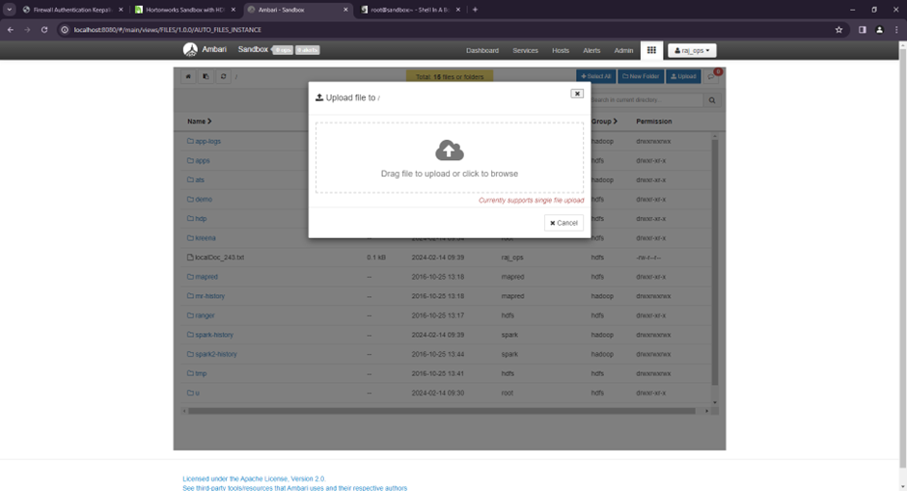

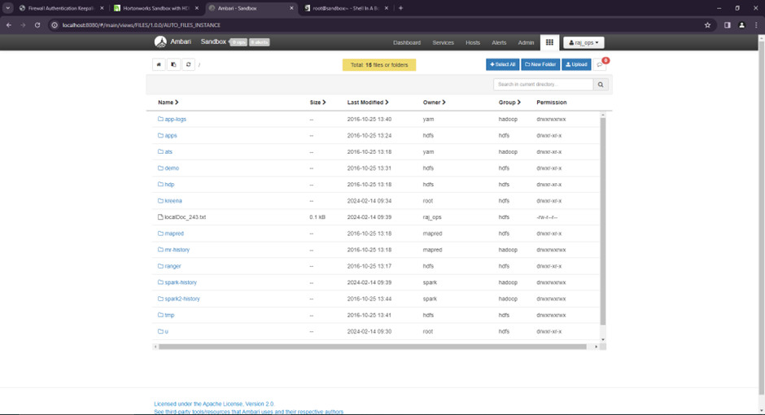

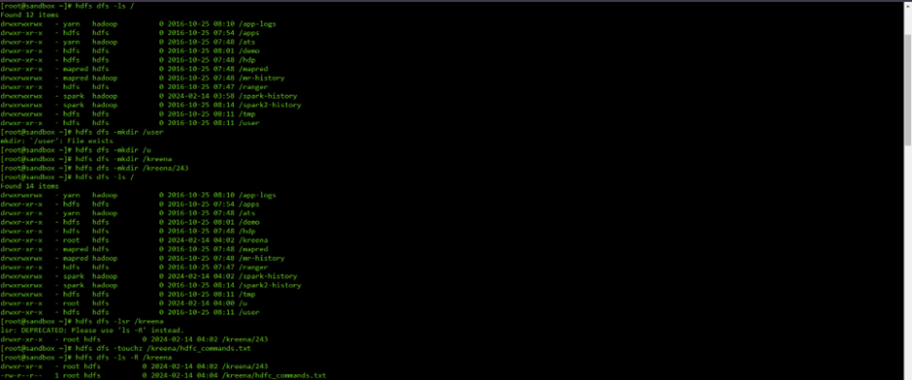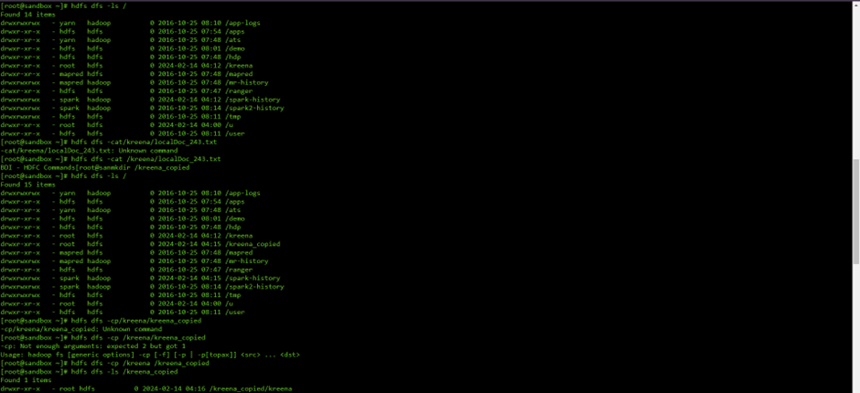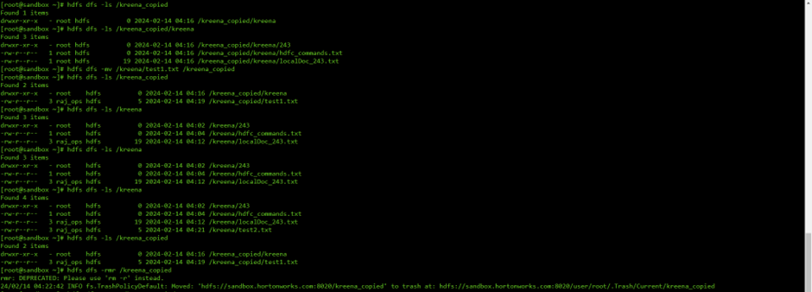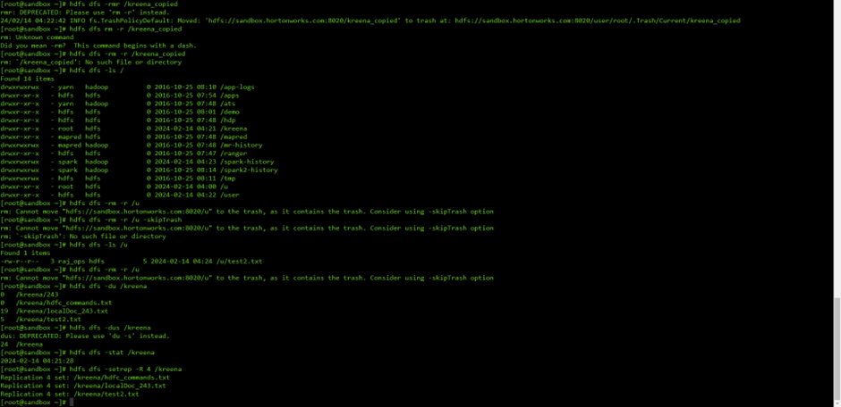

Conclusion : We have successfully execute different HDFS Commands

**Experiment 6**

Aim : Implement Matrix Multiplication and Word Frequency Count using Map Reduce

Theory : 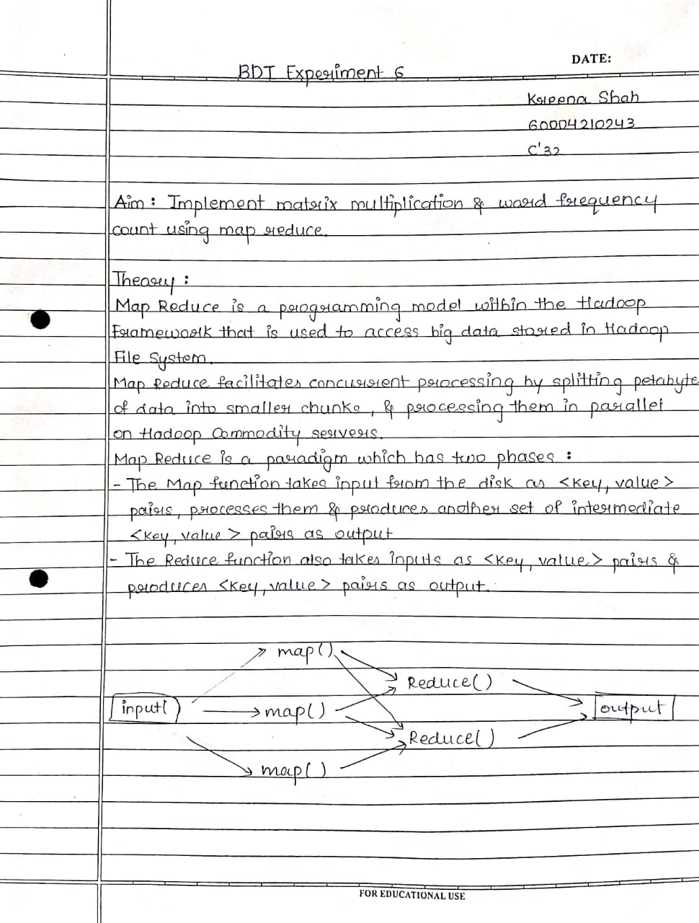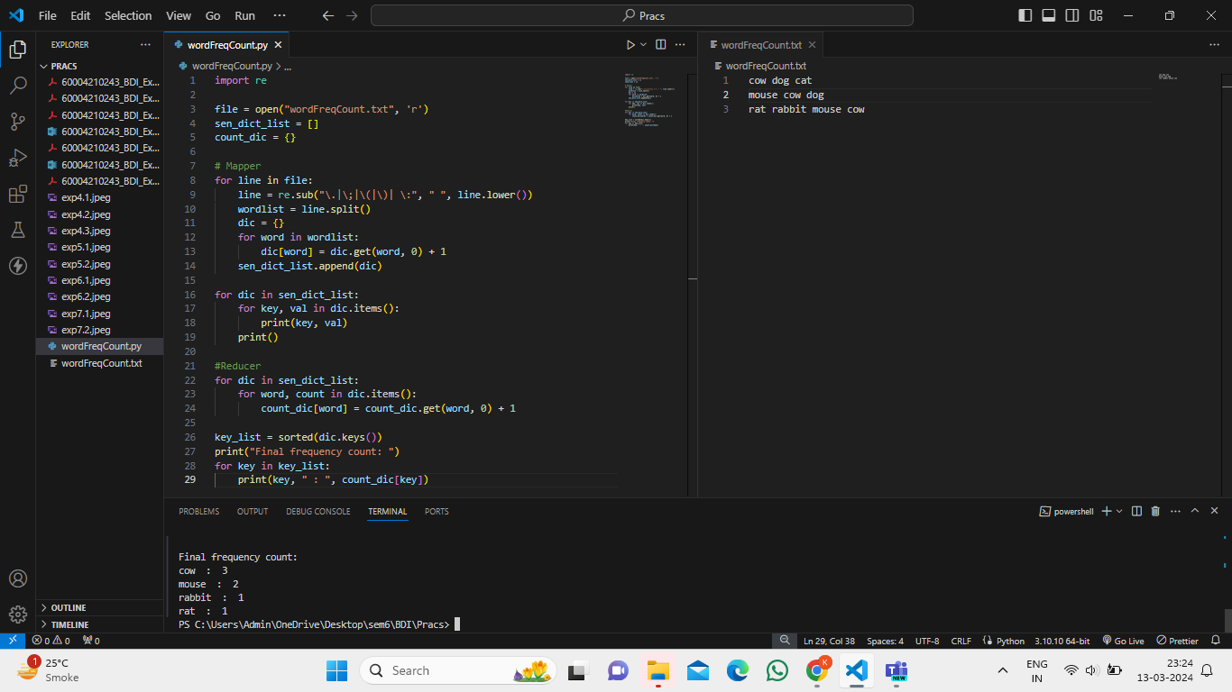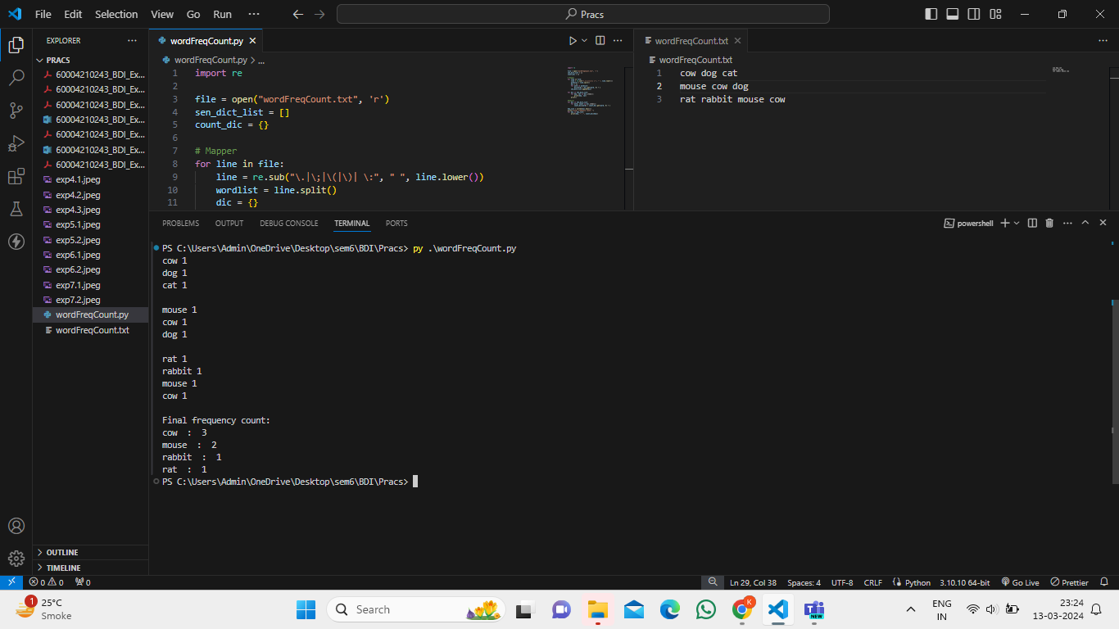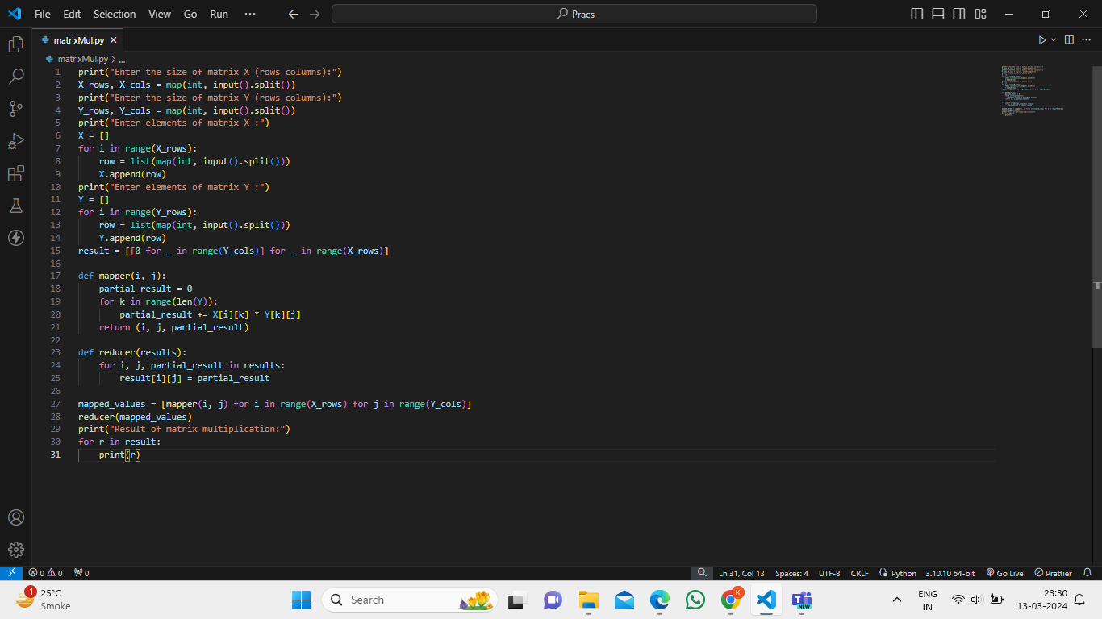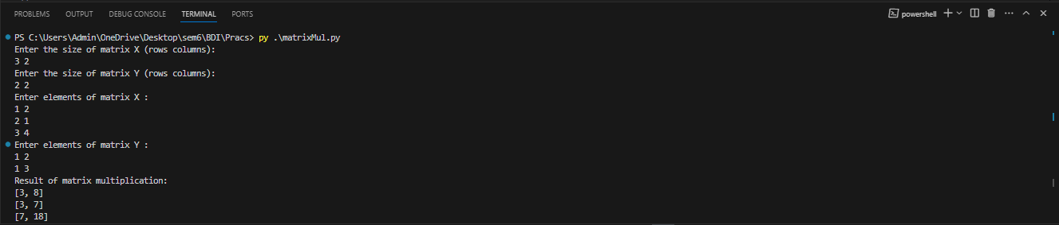

Conclusion : Thus, we implemented Matrix Multiplication and Word Frequency Count using Map Reduce.

**Experiment 7**

Aim : Implement RDD using PySpark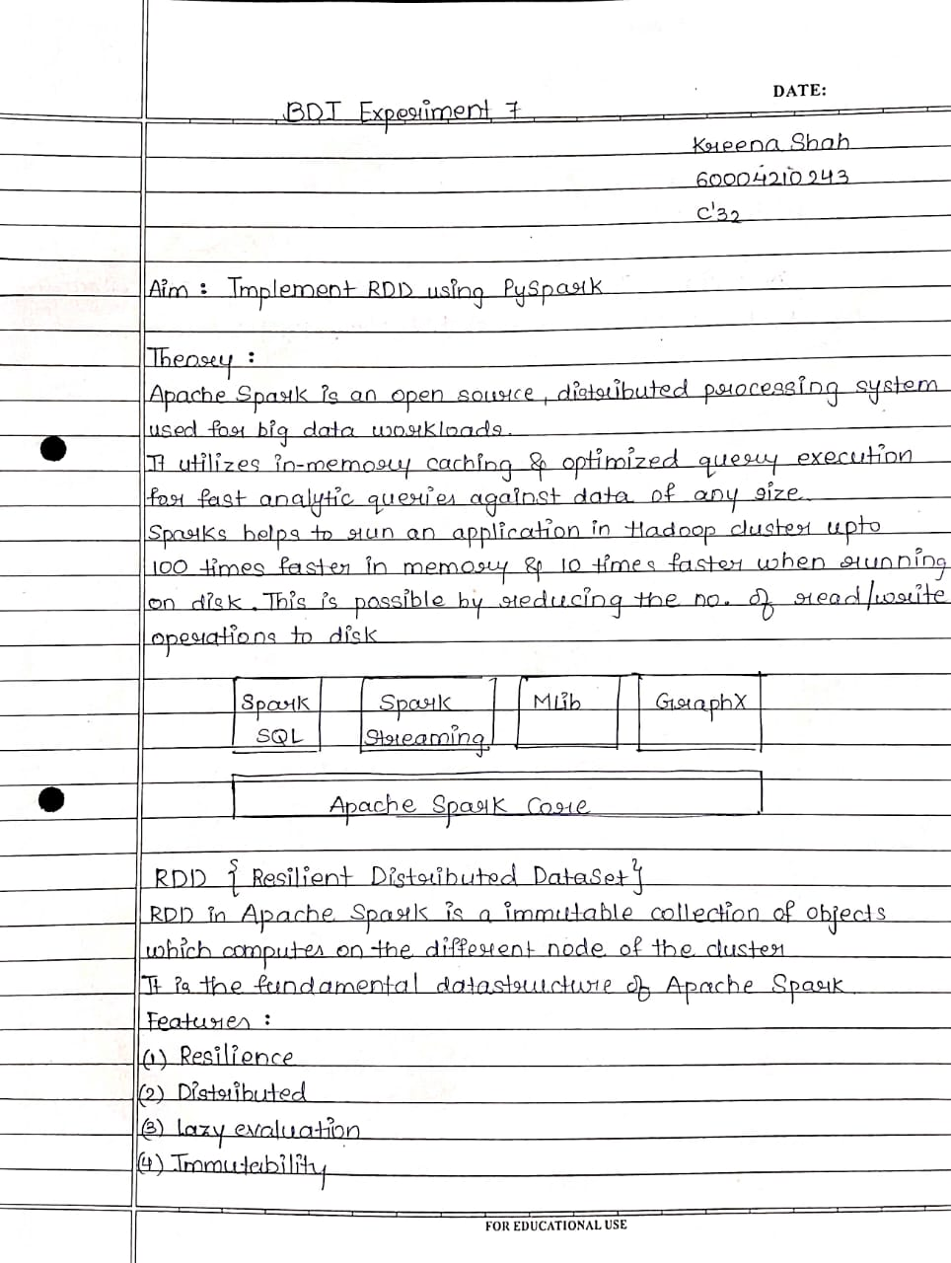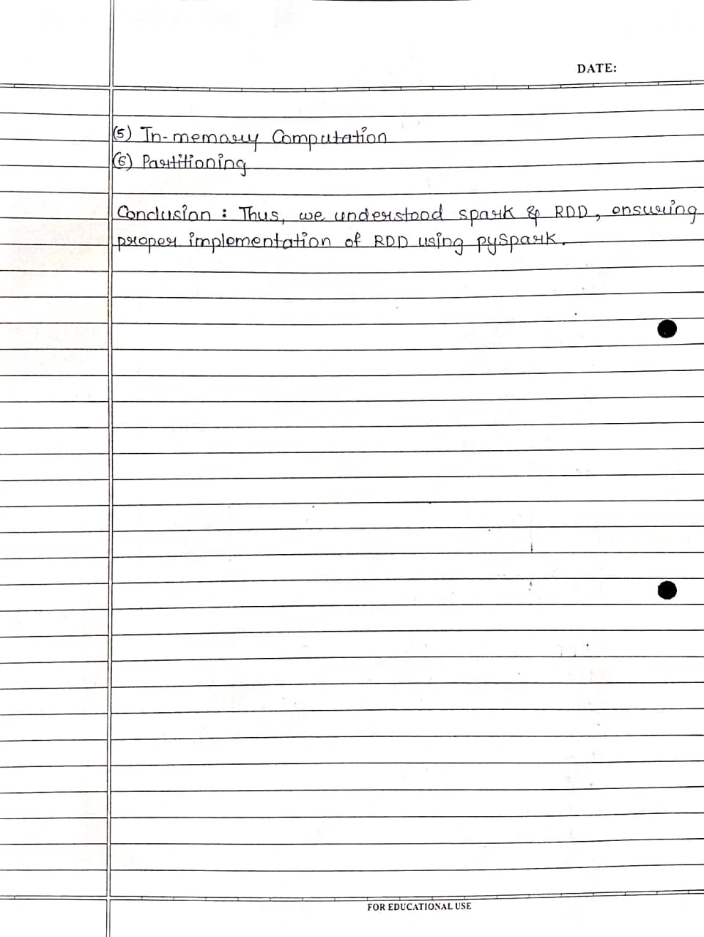**Example 1 :**

**RDD of Squares of numbers [1,2,3,4,5] that are above 10**

from pyspark import SparkContext

sc = SparkContext('local','RDD Example')

numbers = [1,2,3,4,5]

rdd = sc.parallelize(numbers)

squared_rdd = rdd.map(lambda x : x*x )

filtered_rdd = squared_rdd.filter(lambda x : x > 10)

result = filtered_rdd.collect()

print(result)



**Example 2 :**

**Rdd of Square Roots between 1 and 20**

from pyspark import SparkContext, SparkConf

import math

conf = SparkConf().setAppName("SquareRootNumbers").setMaster("local")

sc = SparkContext.getOrCreate(conf=conf)

numbers_rdd = sc.parallelize(range(1, 21))

square_root_rdd = numbers_rdd.map(lambda x: math.sqrt(x))

square_roots = square_root_rdd.collect()

for square_root in square_roots:

print(square_root)

sc.stop()

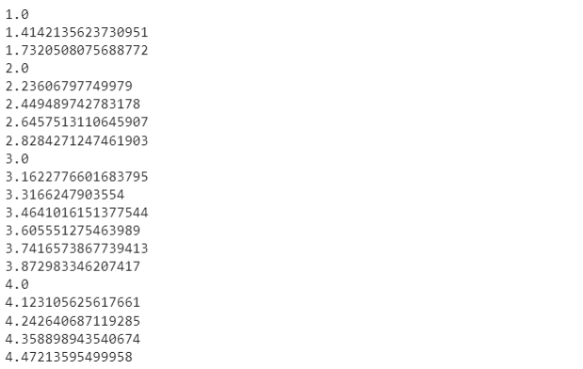

**Example 3 :**

**Rdd of Armstrong number between 100 and 9999**

conf = SparkConf().setAppName("ArmstrongNumbers").setMaster("local")

sc = SparkContext.getOrCreate(conf=conf)

def is_armstrong_number(num):

l = len(str(num))

sum_of_powers = 0

n = num

while n > 0:

digit = n % 10

sum_of_powers += digit ** l

n //= 10

return num == sum_of_powers

armstrong_numbers_rdd = sc.parallelize(range(100, 10000))

armstrong_numbers =

armstrong_numbers_rdd.filter(is_armstrong_number).collect()

print(armstrong_numbers)

sc.stop()

Output :

**Example 4:**

**Rdd of perfect number between 1 and 100**

conf = SparkConf().setAppName("PerfectNumbers").setMaster("local")

sc = SparkContext.getOrCreate(conf=conf)

def is_perfect_number(n):

sum_of_divisors = 0

for i in range(1, n):

if n % i == 0:

sum_of_divisors += i

return sum_of_divisors == n

perfect_numbers_rdd = sc.parallelize(range(1, 101))

perfect_numbers = perfect_numbers_rdd.filter(is_perfect_number).collect()

print(perfect_numbers)

sc.stop()

Output : 



**Experiment 8**

Aim : To study and implement SparkQL using PySpark.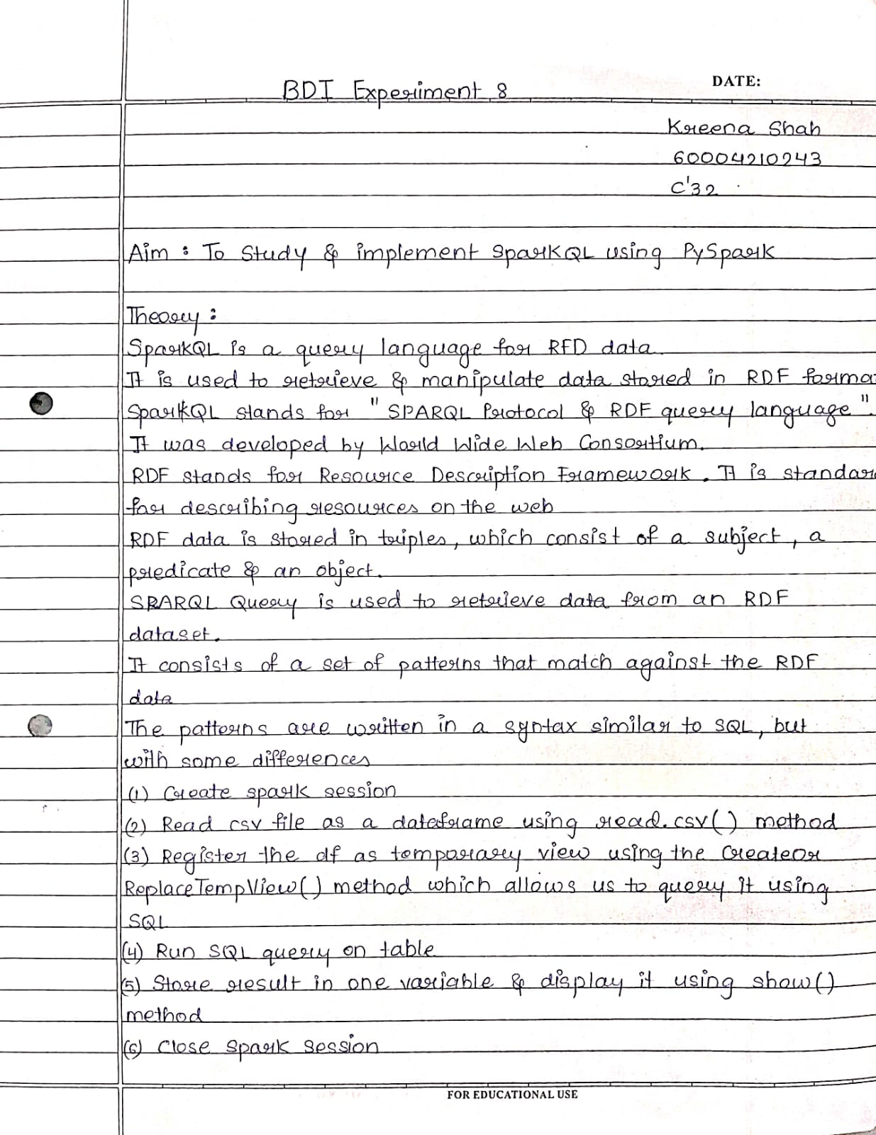

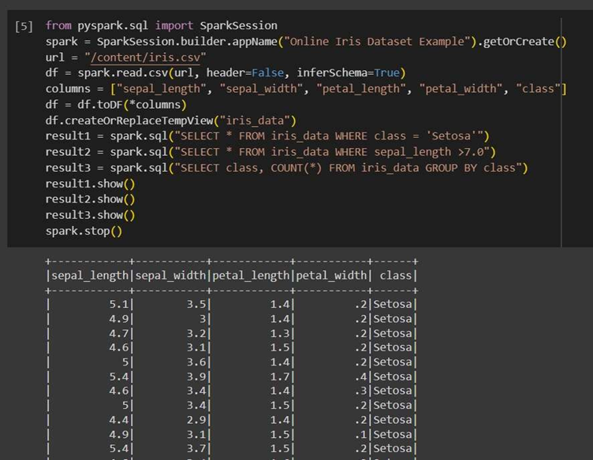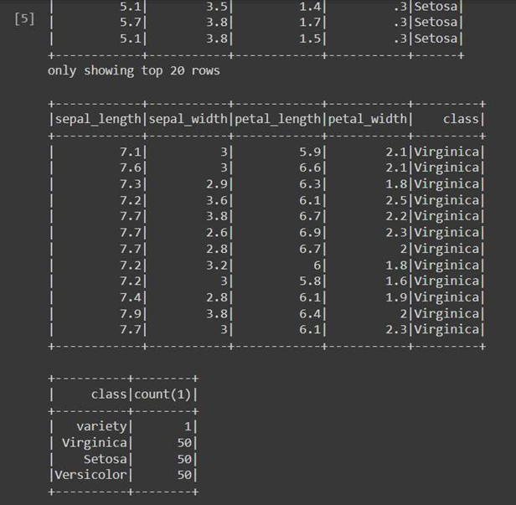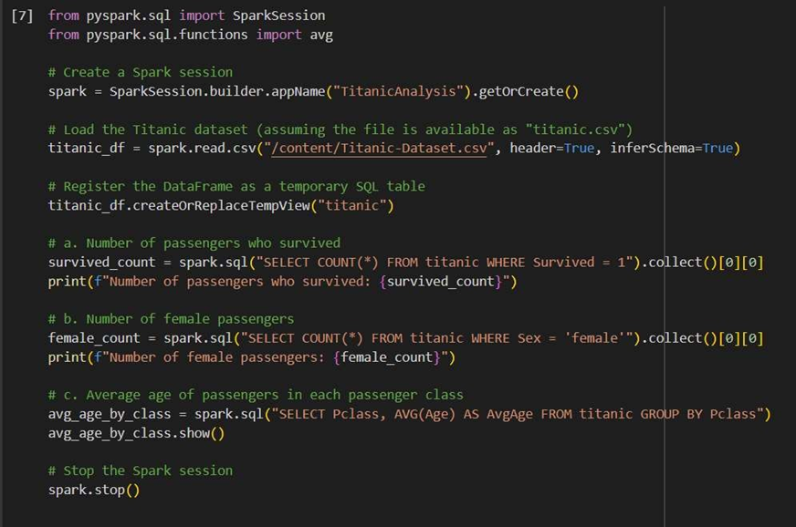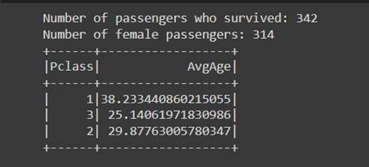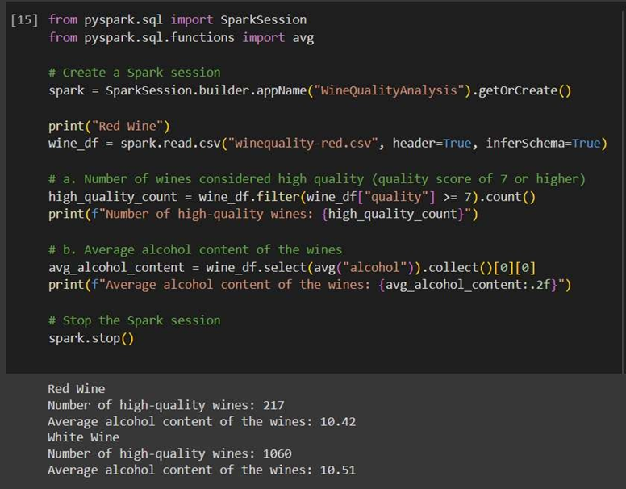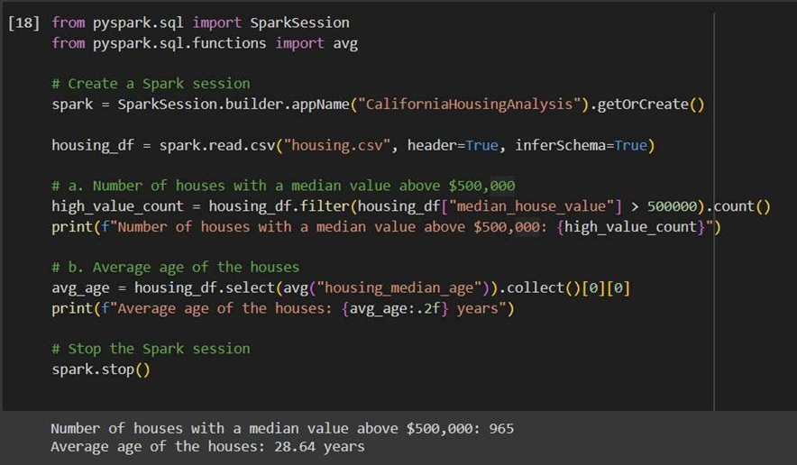

**Experiment 9**

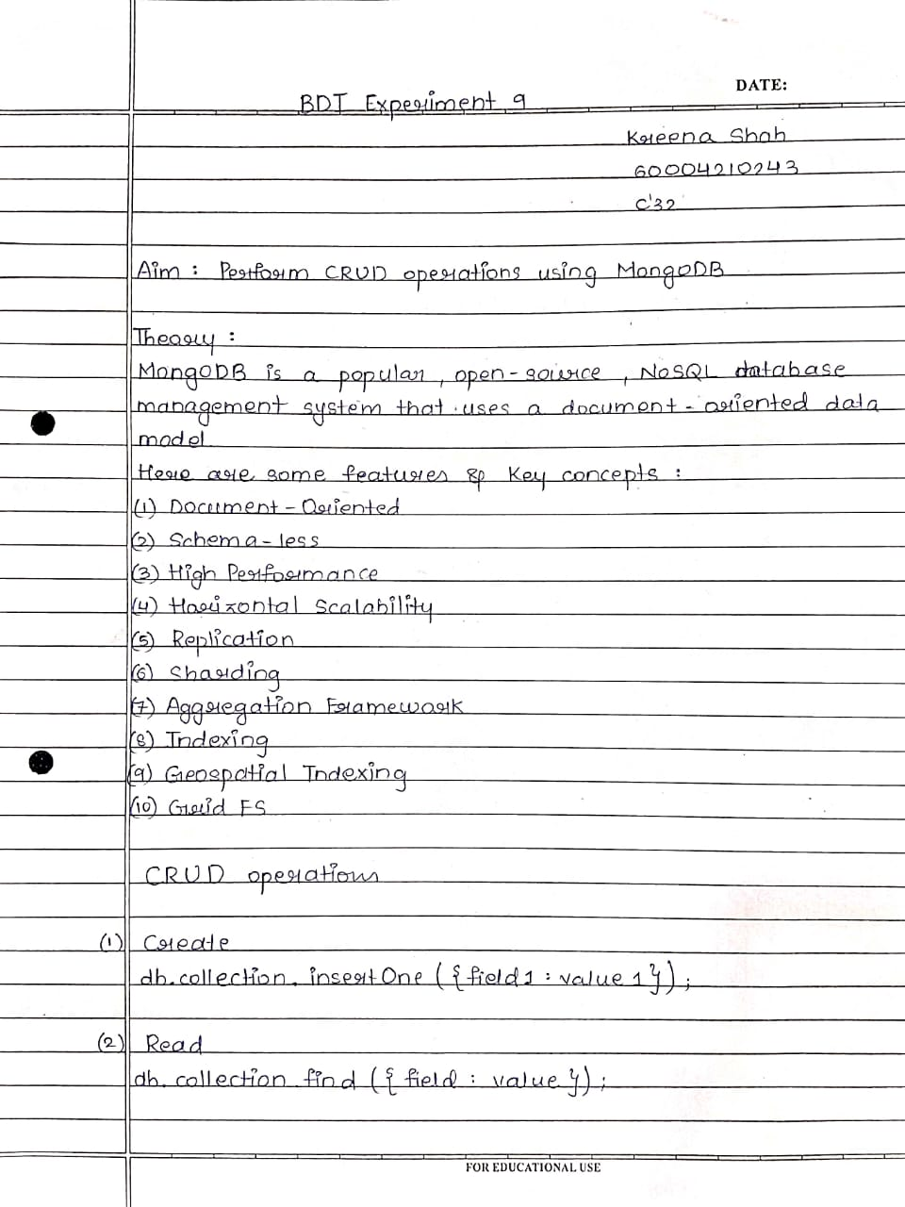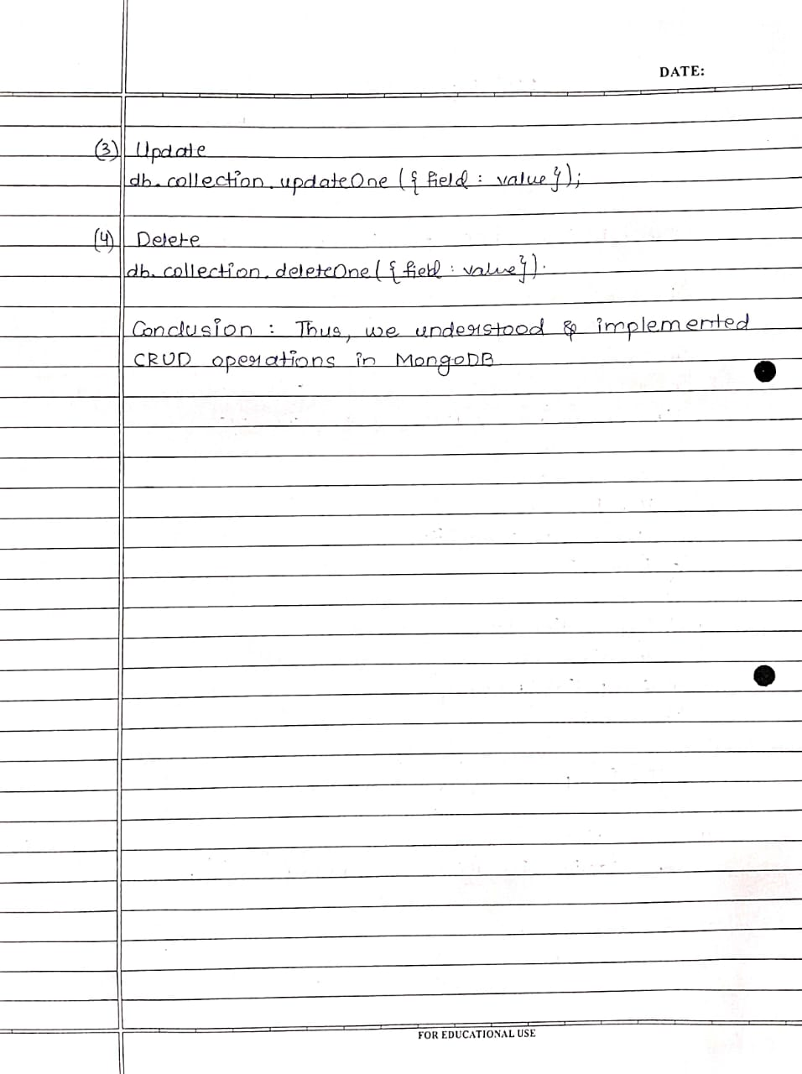Using mongo compass:

MongoDB Compass is a good GUI tool for managing mongoDB collections and doing data queries. It is free to use and can be run on macOS, Windows, and Linux.

A sample data set was created and used in order to test the functionality of the MongoDB database.

1.To show databases present in MongoDB Atlas.

show dbs;

BDA 80.00 KiB

BDA1 8.00 KiB

admin 120.00 KiB

config 60.00 KiB

local 160.00 KiB

myDB 8.00 KiB

poulations 56.00 KiB

test 80.00 KiB

2. To select the database.

use admin;

'switched to db admin'

3. To show all collections present in database.

show collections;

employees Student system.version

4.To create a new collection. db.createCollection('Movie');

{ ok: 1 }

5.To insert a single row in collection.

db.Movie.insertOne({ID:1,Title:"Terminator",Director:"Sanjay",Year:1985, Bud get:25000000});

{ acknowledged: true,

insertedId: ObjectId("64302a42c27158d639b83646") }

db.Movie.insertOne({ID:2,Title:"DDLJ",Director:"Karan",Year:1989,Budget: 200

00000});

{ acknowledged: true,

insertedId: ObjectId("64302a86c27158d639b83647") }

6.To display values in collection. db.Movie.find({ID:2});

{ _id: ObjectId("64302a86c27158d639b83647"),

ID: 2,

Title: 'DDLJ', Director: 'Karan', Year: 1989,

Budget: 20000000 }

db.Movie.find();

{ _id: ObjectId("64302a42c27158d639b83646"), ID: 1,

Title: 'Terminator', Director: 'Sanjay', Year: 1985,

Budget: 25000000 }

{ _id: ObjectId("64302a86c27158d639b83647"), ID: 2,

Title: 'DDLJ',

7.To insert multiple rows in collection. db.Movie.insertMany([{ID:3,Title:"Dabang",Director:"salman",Year:2012,Bu dge t:30000000},{ID:4,Title:"Bagban",Director:"Dharmendra",Year:2010,Budget:

150 00000}]);

{ acknowledged: true, insertedIds:

{ '0': ObjectId("64302b79c27158d639b83648"), '1': ObjectId("64302b79c27158d639b83649") } }

8.To display values in collection. db.Movie.find();

{ _id: ObjectId("64302a42c27158d639b83646"),

ID: 1,

Title: 'Terminator', Director: 'Sanjay', Year: 1985,

Budget: 25000000 }

{ _id: ObjectId("64302a86c27158d639b83647"), ID: 2,

Title: 'DDLJ', Director:

'Karan',

Year: 1989,

Budget: 20000000 }

{ _id: ObjectId("64302b79c27158d639b83648"), ID: 3,

Title: 'Dabang', Director: 'salman', Year: 2012,

Budget: 30000000 }

{ _id: ObjectId("64302b79c27158d639b83649"), ID: 4,

Title: 'Bagban',

Director: 'Dharmendra', Year: 2010,

Budget: 15000000 }

9.To update value in the collection. db.Movie.updateOne({'Title':'Terminator'},{$set:{'Title':'Robot'

}}); { acknowledged: true,

insertedId: null, matchedCount: 1, modifiedCount: 1,

upsertedCount: 0 }

db.Movie.find();

{ _id: ObjectId("64302a42c27158d639b83646"), ID:

1,

Title: 'Robot', Director:

'Sanjay', Year: 1985,

Budget: 25000000 }

{ _id: ObjectId("64302a86c27158d639b83647"), ID: 2,

Title: 'DDLJ', Director: 'Karan', Year: 1989,

Budget: 20000000 }

{ _id: ObjectId("64302b79c27158d639b83648"), ID: 3,

Title: 'Dabang', Director: 'salman', Year: 2012,

Budget: 30000000 }

{ _id: ObjectId("64302b79c27158d639b83649"), ID: 4,

Title: 'Bagban', Director: 'Dharmendra', Year: 2010,

Budget: 15000000 }

db.Movie.find({$and:[{Year:{$lt:"2015-01-01"}},{Budget: {$gt:500000}}]})

9.To find maximum budget movies group by year.

db.Movie.aggregate([{$group : {_id : "$Year", num_tutorial : {$max :

"$Budget"}}}])

{ _id: 1985, num_tutorial: 25000000 }

{ _id: 1989, num_tutorial: 20000000 }

{ _id: 2010, num_tutorial: 15000000 }

{ _id: 2012, num_tutorial: 30000000 }

**Experiment 10**

Aim : Perform Sentiment Analysis Using Kafka